Microwave Measurements

Report Lab

Student Name: Rania Hamada Mohammed

Seat ID: 78

Section: 3

Table of contents

1 Spectrum Analyzer 3

1.1 Principle of working 3

1.2 Specifications of HP 8592B 3

1.3 Usage 3

2 Time interval Analyzer 4

2.1 Principle of working 4

2.2 Specifications 4

2.3 Usage 4

3 Network Analyzer 5

3.1 Principle of working 5

3.2 Specifications 5

3.3 Usage 5

# Spectrum Analyzer

## Principle of working

A spectrum analyzer is considered as a device that is used for the analysis of the amplitude of the signal with respect to frequency. The amplitude is represented vertically on a logarithmic scale. While the frequency can be represented on logarithmic or normal scale horizontally. The use of a logarithmic scale on the vertical axis allows judgement of large differences in amplitude of various signals.

The signal to be analyzed is provided to the RF attenuator which sends the optimum signal to the mixer. The mixer combines the input signal and the signal received from the local oscillator to generate a signal of intermediate frequency.

Further, the signal is provided to the IF filter whose output is provided to the detector so that the signal can be detected at the tuned frequency. The voltage at the output of the detector shows the amplitude of the signal and drives the y-axis of the plot to be displayed.

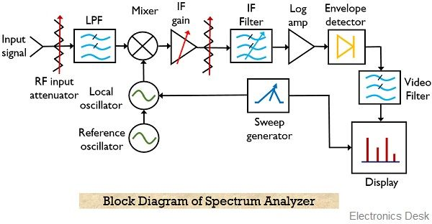The synchronization between the sweep generator and LO provides the frequency response. This leads to producing, amplitude vs frequency plot at the LCD display of the analyzer.

## Specifications of HP 8592B

|  |  |
| --- | --- |
| Frequency Range | 9 kHz to 22 GHz; 9 kHz to 25 GHz (option H25) |
| Span Range | 0 Hz (zero span), (50 X N) kHz to 19.25 GHz |
| Sweep Time Range | 20 ms to 100 s |
| Amplitude Range | -114 to +30 dBm |

## Usage

The swept receiver type of spectrum analyzer finds applications in various fields such as telecommunication equipment, mobile communication system, and broadcasting equipment. Along with this, spectrum analyzers are used in microwave communication links, radar, and cable TV systems, etc.

# Time interval Analyzer

## Principle of working

Time Interval is an important measurement frequently made with electronic counters. In this role, the counter makes an elapsed time measurement between two electrical pulses, just as a stopwatch is used to time physical events. Minimum time measurement is much less (to a nanosecond and below) than possible with a stopwatch. Also, resolution and accuracy are much greater than attainable with a stopwatch.

The time interval analyzer uses a clock with a specific period. Using the clock, it counts the time interval between any two given rising or falling edges on the slopes of a signal being measured, depending on the measurement function. Since, in general, signals that are being measured are asynchronous to clocks, there are zones of time (time intervals shorter than the clock period) which cannot be counted with a clock. These time zones are called fractional times. Fractional times lie at the starting and ending edges of a measurement interval.

The timer interval measurement capabilities of time interval counters can be used in a variety of ways.

* **Time interval of waveform**: The frequency timer counter can be used to simply measure the time interval of the incoming waveform. This is simply the reciprocal of the frequency. It typically measures the positive going edge of the waveform to the next positive going edge.
* **Time interval of pulse**: Rather than simply measuring one positive going edge to the next, it is also possible to measure a positive going edge to the next negative going one. Or alternatively it could measure a negative going edge to a positive one. In this way it is possible to use the frequency timer counter to measure the time interval of a pulse.
* Time interval A to B: Many counter timers have two inputs. In this way it is possible to measure an edge on one signal to an edge on another. Normally it is possible to select either positive or negative going edges on each signal.

## Specifications

|  |  |
| --- | --- |
| Frequency Range | 125 milli-Hz to 500 MHz; Up to 2GHz with channel C |
| Time interval Range | Up to 8 s with 150 ps rms resolution |
| Wide-band modulation | Up to 10 MHz continuous sample rate |

## Usage

It performs many measurements:

* Single-shot, precision VCO characterization (settling time, over-shoot, and post-tuning drift)
* Jitter analysis (time deviation and FFT displays)
* Phase-locked loop studies (rise time, ringing, over-shoot, and settling time)
* Frequency stability measurements

# Network Analyzer

## Principle of working

The network analyzer (NWA) system is an accurate tracking oscilloscope read out. It displays amplitude and phase versus frequency. It's actually a very short distance communication system in which receiver tracks transmitter.

The network analyzer is an instrument which measures the complex transmission and reflection characteristics of two-port devices in the frequency domain. It samples the incident signal, separating the transmitted and reflected waves, and then performing ratios that are directly related to the reflection and transmission coefficients of the two-port. Frequency is swept to rapidly obtain amplitude and phase information over a band of frequencies of interest.

It consists of three main parts: Tunable Transmitter Unit (TTU), Test Transmission Medium (TTM), Swept Receiver Unit (SRU). TTU generates the required transmitted and control signal, it generates three signals: VTO signal directed o the SPU, RF signal directed to TTM, and horizontal sweep signal directed to the display unit. TTM has a power splitter that splits the power into R&T-channel and provides matching between the TSG in the TTU and the R&T-channel inputs. Then, the SPU receives the signal from R&T channels and processes them to display the amplitude and phase response on the display unit.

## Specifications

|  |  |
| --- | --- |
| Frequency Range | 130 MHz - 20 GHz |
| Frequency Resolution | 1 Hz (Opt.001) |
| Output power range | -65 to - 10 dBm |
| Display | Colored |

## Usage

It's suitable for the measurement of magnitude and phase characteristics of networks, components and devices by comparing the incident signal with the transmitted signal from the unit under test (UUT).

It can be used to determine the transmission properties of a system like the insertion loss, insertion phase shift and time delay, and the reflection propertied like complex impedance, reflection coefficient and VSWR, it’s also used to determine the frequency response, phase shift.